TOWN
Of

Milltown
Polk County, Wisconsin

ORDINANCE No. 2021-1 DESIGNATING CERTAIN TOWN ROADS
IN THE TOWN OF Milltown AS "CLASS B" HIGHWAYS
The Town Board of the Town of MILLTOWN, POLK County, Wisconsin, has the specific authority under s 349.15 (2), Wis. stats., to adopt this ordinance numbered 2021-1.
SECTION I. - GENERAL PURPOSE
The purpose of this ordinance is to ensure the safety of the individuals living within the town and those individuals who use the town roads, by preventing frequent travel of large vehicles on the town roads other than for regular delivery within the town.
SECTION II. - ADOPTION OF STATE STATUTE
Chapters 348 and 349 Wisconsin Statute 2020-21, and any amendments thereto including words and definition; enforcement provisions, and penalties, are hereby adopted.
SECTION III. - AUTHORITY
The Town Board of the Town of Milltown has specific statutory authority under Wis. Stats.
349.15 to impose weight limitations on highways within its jurisdiction to protect the constructional integrity and the safety of those individuals using the town roads.
SECTION IV. -DESIGNATION OF ROADS
The following town highways in the Town of MILLTOWN are designated class "B" highways subject to the weight limits set forth in s. I' 1 1, Wis. stats., [no person, without a permit therefor, shall operate on a class "B" highway any vehicle or combination of vehicles imposing wheel, axle, group of axles, or gross weight on the highway exceeding 60 percent of the weights authorized in
s. 348.15 (3)] unless increased by town ordinance:
l. 120th St from 190th Ave to Termini
- 190th Avenue from 120th St to State Highway 35
- 200th Ave from Termini to State Highway 35
- 170th Street From 180th Ave to 240th Ave Not Including Village Limits
- 140th Street from 190th Ave to 200th Ave
- 140th Street from County Road G to 220th Ave
- Kemoh Park Drive from 180th Ave to 138th St
- 138th Street from Kemoh Park Drive to 185th Ave
- 195th Ave from State Hwy 46 to 160th St
- 160th St from State Hwy 46 to 180 Ave
- 150th St from State Highway 46 to 230th Ave
- 185th Ave from 138th Street to 145th Street
- 220th Ave from State Highway 46 to GG
- 210th Ave from State Hwy 35 to 160th Street
- 235TH Ave from Hwy GG to 145th St.

The town chairperson, or his or her designee, shall place appropriate traffic signs on the above-
described highways on or before the effective date of September 1, 2021, for this ordinance.

SECTION V. - PENALTY PROVISIONS
No person may operate any vehicle on the above-noted highways in violation of the weight limits set forth in s.348.116 (2), Wis. stats. Upon conviction for a violation of this ordinance, the violator shall pay a forfeiture penalty, pursuant to Wisconsin Statute plus the applicable surcharges, assessments, and costs for each violation. Each trip in violation of this ordinance constitutes a separate offense. In addition, the town board may seek injunctive relief from a court of record to enjoin further violations.
SECTION VI. -ENFORCEMENT
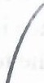
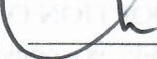
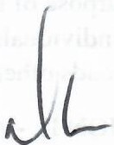
In addition to those police and traffic officers designated in Section 349.02 Wis. Stat. 2020-21, the Town Board may by resolution designate such other person or persons to enforce this ordinance.
J
Adopted this 12^{th.}day of July 2021.
Updated April 8th, 2025
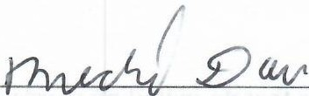

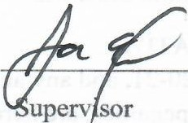
Attest:
Town Chair
Town Clerk
Supervisor

